MIT Assignment-03

Jeetu Mehra
U24AI032

Question 1 : Write instruction to copy data into register B from memory location 0008H specified by HL pair.
Output:
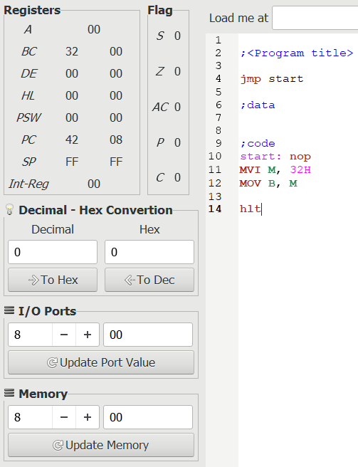
Question 2: Write instruction to copy data from register B into memory location 0008H specified by HL
pair.
Output:
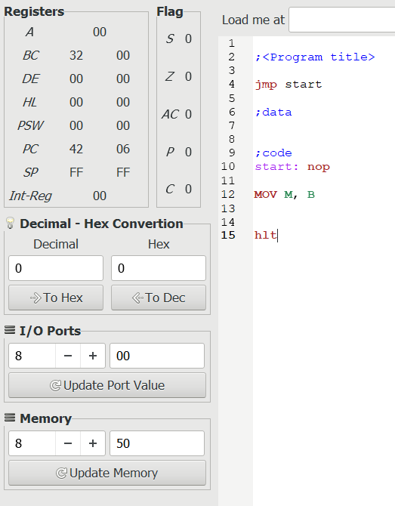

Question 3: Write instruction to add contents of register B to the contents of A and show results at I/O port
address 0002H.
Output:

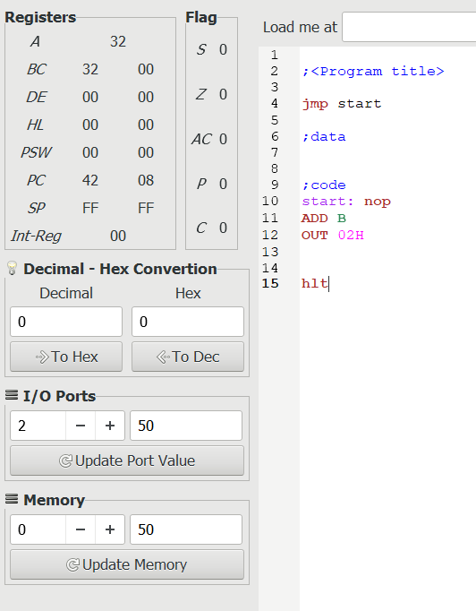
Question 4 : Write instruction to add 8-bit data to the contents of A and show results at memory address
003FH.
Output:
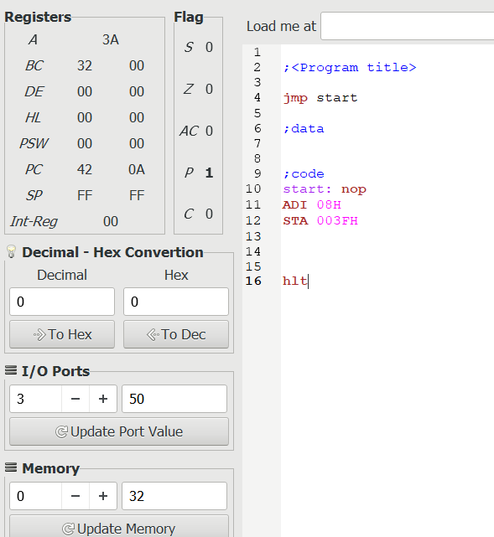

Question 5 : Write instruction to add contents of memory address specified by HL pair to the contents of A
Output:
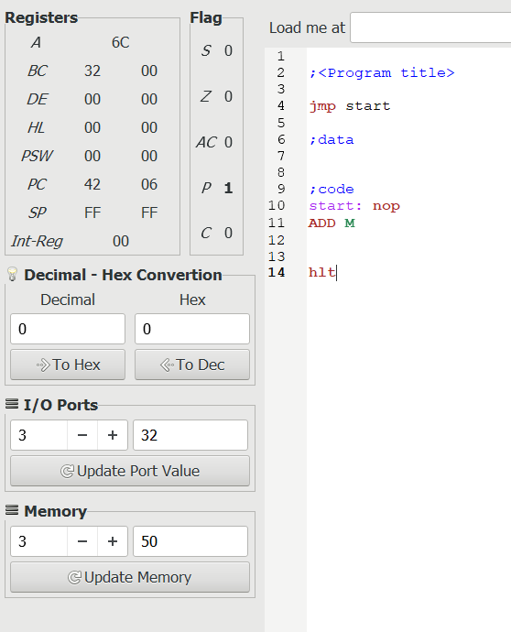

Question 6 : Write instruction to subtract contents of register B from the contents of A and show results at
I/O port address 0002H.
Output:
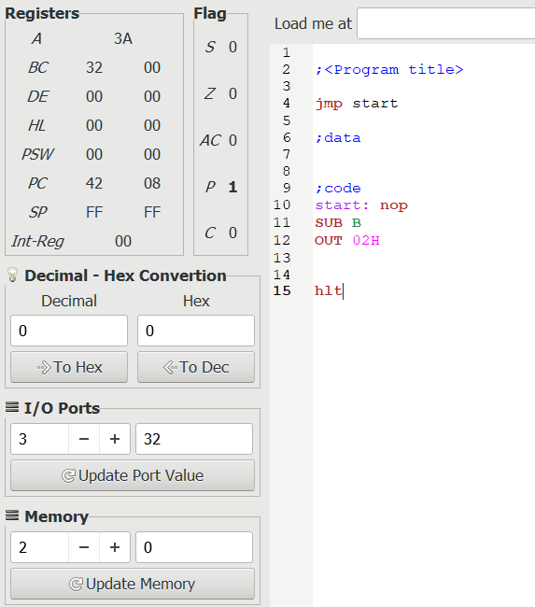

Question 7 : Write instruction to subtract 8-bit data from the contents of A and show results at memory address 003FH.
Output:
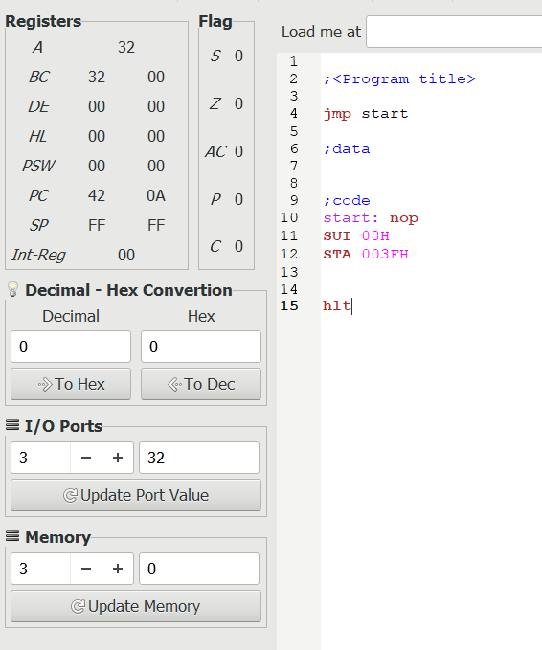

Question 8 : Write instruction to subtract contents of memory address specified by HL pair from the contents of A
Output:
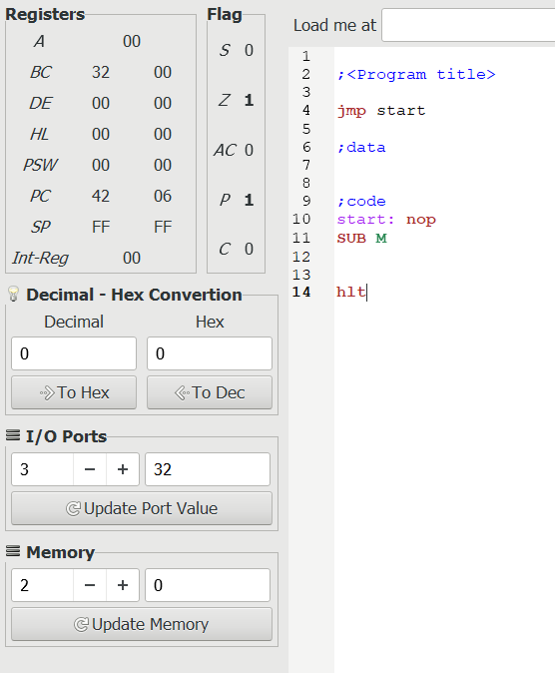

Question 9 : Write instruction to copy data (results)from accumulator to memory location 0008H.(STA)
Output:
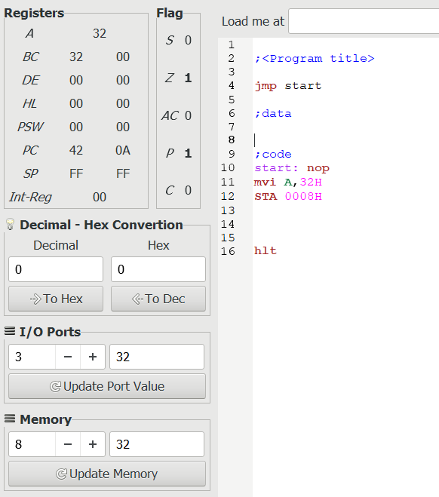

Question 10 : A. load data 93H to memory location 003E H.
B. load data B7H to memory location 0005H.
C. Add both data and show results at I/O port 007FH.
Output:
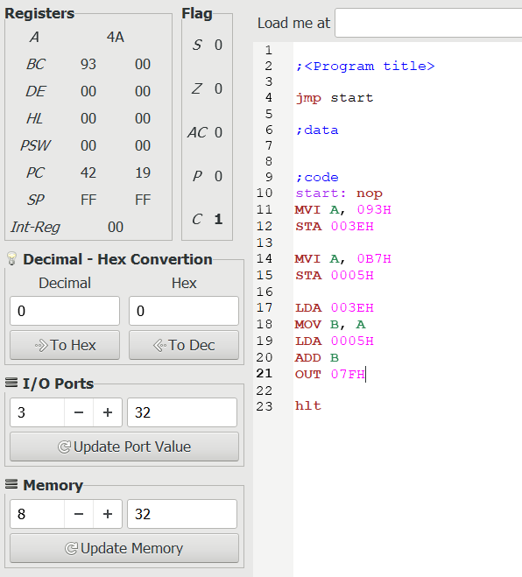

Question 11: A. load data 4FH to memory location 7F H.
B. load data 78H to I/O port 0005H.
C. Add both data and show results at I/O port 007FH.
Output:
